**Adventure Works Database for OLTP and DW**

* Query result of AdventureWorksDW2014 database.

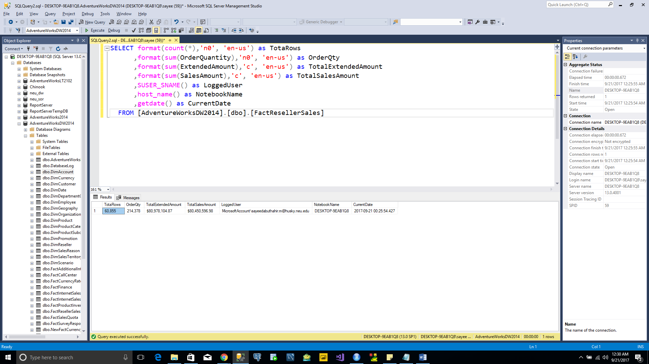

* Query Result of AdventureWorks2014 database.

